Data Flow Diagrams:

# Project Design Phase-II

**Data Flow Diagram & User Stories**

|  |  |
| --- | --- |
| Date | 13 October 2022 |
| Team ID | PNT2022TMID27467 |
| Project Name | News Tracker Application |
| Maximum Marks | 4 Marks |

Simplified: DFD Level 0 (Industry Standard):

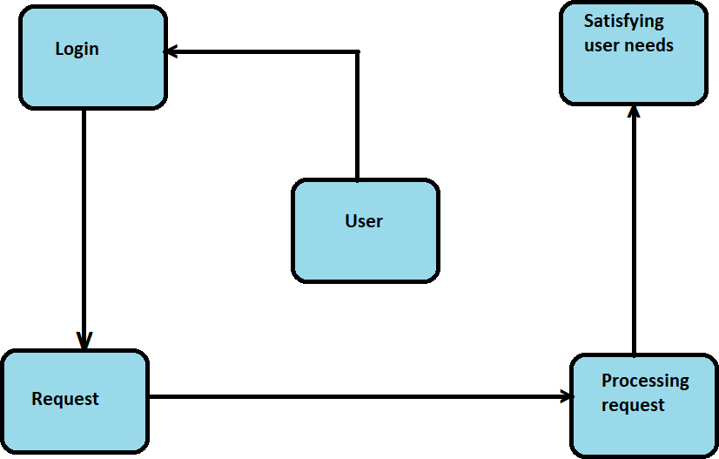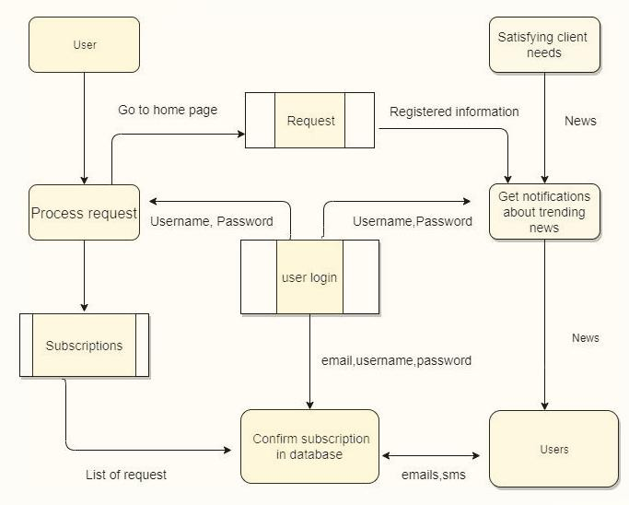

User Stories

|  |  |  |  |  |  |  |
| --- | --- | --- | --- | --- | --- | --- |
| **User Type** | **Functional**  **Requirement (Epic)** | **User Story Number** | **User Story / Task** | **Acceptance criteria** | **Priority** | **Release** |
| Customer (Mobile user) | Registration | USN-1 | As a user, I can register for the application by entering my email, password, and confirming my password. | I can access my account / dashboard | High | Sprint-1 |
|  |  | USN-2 | As a user, I will receive confirmation email once I have registered for the application | I can receive confirmation email & click confirm | High | Sprint-1 |
|  |  | USN-3 | As a user, I can register for the application through Gmail | I can register through Gmail by OTP authentication | Medium | Sprint-2 |
|  | Login | USN-4 | As a user, I can log into the application by entering email & password | I can view all types of information through this application | High | Sprint-1 |
|  | Dashboard | USN-5 | To see their histories about recently viewed, updates for search related news, current progress, feedback |  | Medium | Sprint-2 |
| Customer (Web user) | Browser | USN-6 | Works as an interactive medium between client and server | I can access the resources through browser | High | Sprint-1 |
| Customer Care Executive | Chat bot | USN-7 | Rectify the customer’s issues related to account, subscription and customization | Chat bot can resolve simple issues for customers | Low | Sprint-2 |
| Feedback | Feedback Form | USN-8 | Getting feedback from customers helps application’s administrator to improve the quality of the application | Customers can tell their opinions | High | Sprint-1 |
| Administrator | Admin module | USN-9 | As an admin, I will modify the application as per customer requirements and fix the bugs to give customers a bug free service | I can modify the entire application | High | Sprint-2 |